МУНИЦИПАЛЬНОЕ АВТОНОМНОЕ

ОБЩЕОБРАЗОВАТЕЛЬНОЕ УЧРЕЖДЕНИЕ

«СРЕДНЯЯ ОБЩЕОБРАЗОВАТЕЛЬНАЯ ШКОЛА № 5»

ГОРОДА КОГАЛЫМА

Конспект урока

по английскому языку

по теме «Great British Sporting Events!»

в 10 А классе

Учитель иностранных языков

Караваева А.А.

первая категория

**Класс:** 10а.

**Предмет:** английский язык.

**Тема урока:** Great British Sporting Events!

**Тип урока:** Урок первичного предъявления новых знаний.

**Цель урока:** Развитие иноязычной коммуникативной компетенции в процессе знакомства со знаменитыми спортивными событиями страны изучаемого языка.

**Задачи урока:**

1. **Практическая:** активизировать лексический материал по теме Sport;
2. **Образовательная:** расширение общекультурного кругозора средствами иностранного языка;
3. **Воспитательная:** активизировать познавательную инициативу обучающихся и формировать их социальную компетентность;
4. **Развивающая:**  развивать умение детей самостоятельно получать знания; развивать мыслительные операции: анализ, синтез, сопоставление, классификация.

**Оснащение учебного занятия:** Компьютер, проектор, учебник, презентация, раздаточный материал.

|  |  |  |  |  |  |
| --- | --- | --- | --- | --- | --- |
| Этап | Время | Предполагаемая речь учителя | Предполагаемая речь учеников | Запись на доске | Пед  модель |
| I.Начало урока.  Орг.момент  II.Основной этап    Физкультминутка  III. Рефлексия. Окончание урока. | 5 мин  30 мин  1 мин  4 мин | Good afternoon, boys and girls! I am glad to see you. Sit down please. Please answer my questions.  What day is it today?  What date of the week is it today?  Who is absent?   Look at the picture. (см. Приложение 1) What can you say? Can you guess what we are going to talk about today? Right, about sport. It’s very important to be healthy. Many people nowadays talk about a healthy lifestyle. If you want to have a good health, to be strong and physically fit you should do sports of course.  By the end of the lesson you will have learned about:   * Famous British sporting events, * The time and place of these events, * The number of participants, * What else people can do except doing and watching sport.   By the way, do you like sport? What is your favourite kind of sport? Do you go in for sport? What do you prefer? Who is your favourite sportsman?  Look at the screen and answer my question Which sports need this equipment?  Let’s pass over to the next task. Open your books. World List at p. WL7. Read the words after me all together.  Now translate the words from Russian into English.  Let’s pass over to the next task.Now open your books at p 39. ex 1. We listen about The Oxford and Cambridge Boat Race.  Look at the pictures and you can see how this event is hold.  Now we listen about The London Marathon. Look at the pictures and you can see how this event is hold.  Now we listen about Royal Ascot.  Look at the pictures and you can see how this event is hold.  Now we listen about Wimbledon.Look at the pictures and you can see how this event is hold.  Listen once again. Listen attentively, please.  Now let’s have a rest and do some exercises for your eyes.  I give you sheets of paper.Now tell me what these figures stand for. Match the figures with numbers. I give you three minutes to do the task.(см. Приложение 2)  Your time is up. Now we check your answers.  Let’s pass over to the next task. Take please sheets of paper and match the words in bold in the text to their meaning. I give you five minutes to do the task.(см. Приложение 3)  Your time is up. Exchange your sheets of paper with your neighbours, look at the screen and check your answers.  Look at the screen and answer my question.  У нас есть футбольное поле,футболисты и футболистки. Так же у нас есть ворота, каждые ворота имеют свое значение.  Правые ворота -мне все понятно,я молодец!  Левые ворота- у меня не все получилось, но я старался!  Скамейка запасных-мне надо быть внимательнее!  You worked very well today. Now listen to your marks  Igor a five…..  Open your progress book and write down your home task. Look at the screen. Your home task is to write down a short message. | * Hello, teacher. * Today is the 12th of October. * It is Wednesday. * All are present.   We are talking about sport.  I like sport very much. I fond of tennis. My favourite sportsman is Maria Sharapova.  Gloves-boxing  Ball -football  Bat, ball and gates-cricket  Ball-rugby  Racquet and ball -tennis  Rackets and shuttlecocks- badminton  Clubs-golf  Brooms and stone curling  18 - competitors must be students at Oxford or Cambridge University  42 km – Marathon distance  40,000-people take part in the Marathon  300,000-people buy tickets to watch the races  28,000-kilos of strawberries  7,000-liters of ice cream are sold.   1. E 2. O 3. C 4. H 5. M 6. B 7. L 8. N 9. G 10. D 11. F 12. A 13. K 14. I 15. J | The 12th of October.  Wednesday.  На слайде картинка с различными видами спорта. | T – Cl  T – P1, P2,P3…  T – Cl  T – P1, P2,P3…  T – Cl  T – P1, P2,P3…  T – P1, P2,P3…  T – Cl  T – P1, P2,P3…    T – P1, P2,P3…  T – Cl  T – P1, P2,P3…  T – Cl  T – P1, P2,P3…  T – Cl |

Приложение 1

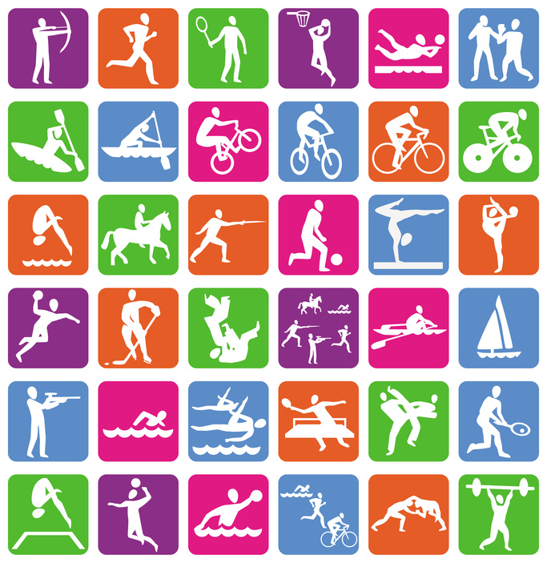

Приложение 2

18 - liters of ice cream are sold.

42 km – people buy tickets to watch the races

40,000-Marathon distance

300,000-people take part in the Marathon

28,000-kilos of strawberries

7,000-competitors must be students at Oxford or Cambridge University

Приложение 3

1. Competitors – a) a competition to find the best player(s) in a sport
2. Extremely – b) most
3. Get out of breath –c) breath very quickly and with difficulty
4. Take part in – d) talk about, give an opinion on
5. Offers – e) people taking part in a contest
6. Majority – f) fashionable
7. Raise money for charity – g) people who introduce a TV programme
8. Race course –h) be involved in
9. Presenters –I) wait in a line to be served/for your turn
10. Comment on – j) play against each other
11. Smart – k) people who watch a sporting event
12. Championship – l) make money for those less fortunate
13. Spectators – m) gives
14. Queue – n) a place where horses run against each other
15. Compete – o) very much